# ELEMENT SELECTOR

<html><head><style>

p { text-align: center;

color: red;}

</style></head><body>

<p>Every paragraph will be affected by the style.</p>

<p id="para1">Me too!</p>

<p>And me!</p>

</body></html>

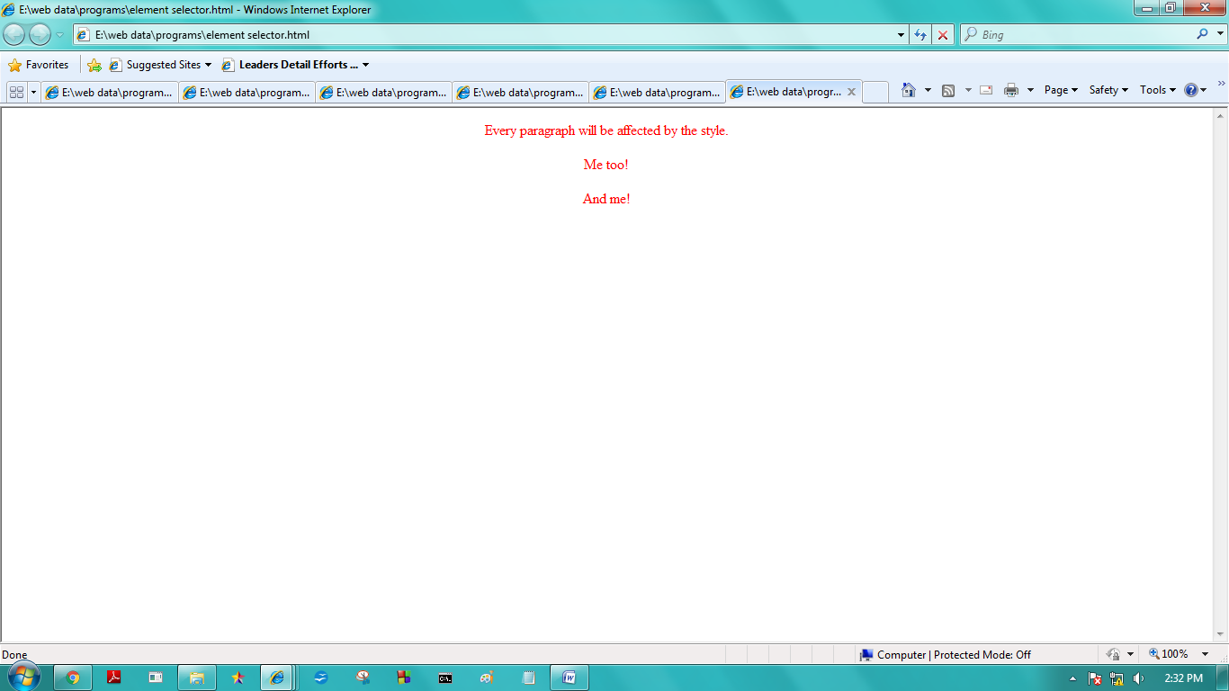

# CLASS SELECTOR

<!DOCTYPE html>

<html><head><style>

.center {

text-align: center;

color: red;}

</style></head><body>

<h1 class="center">Red and center-aligned heading</h1>

<p class="center">Red and center-aligned paragraph.</p>

</body></html>

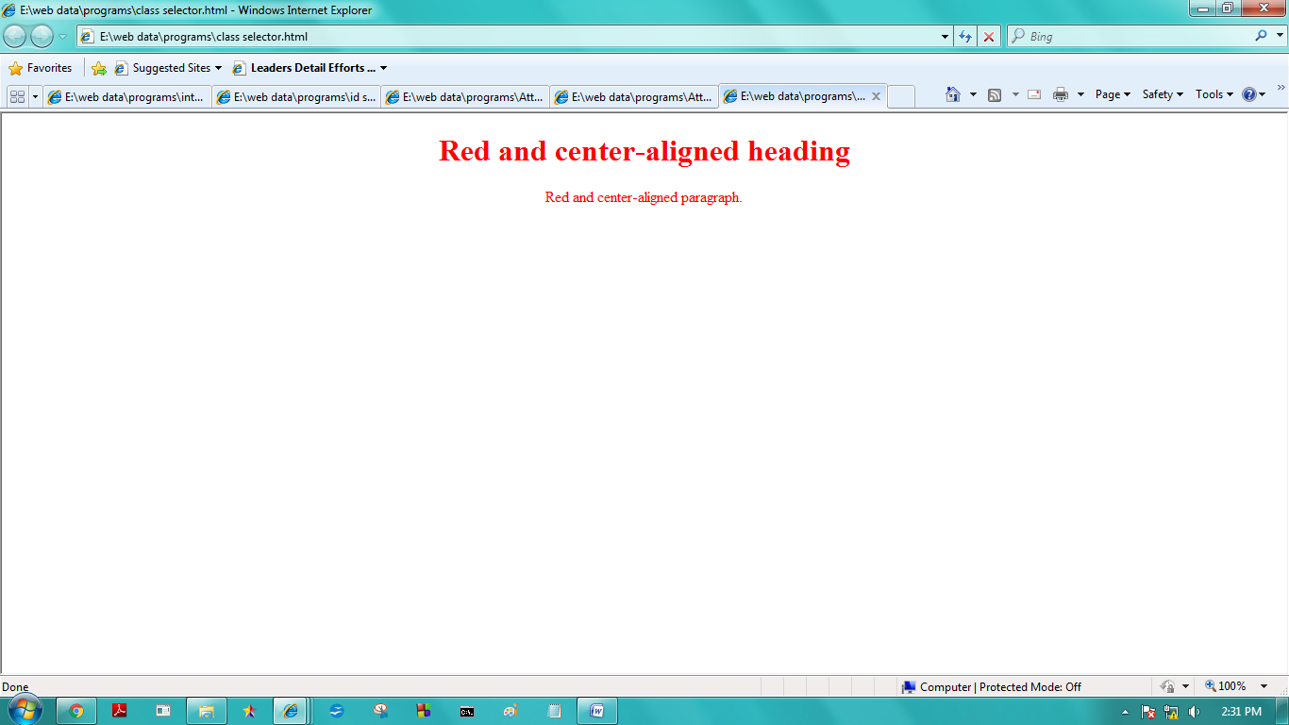

# ATTRIBUTE SELECTOR

<html><head><style>

a[target] { background-color: yellow }

</style></head><body>

<p>The links with a target attribute gets a yellow background:</p>

<a href="https://www.w3schools.com">w3schools.com</a>

<a href="http://www.disney.com" target="_blank">disney.com</a>

<a href="http://www.wikipedia.org" target="_top">wikipedia.org</a>

<p><b>Note:</b> For [<i>attribute</i>] to work in IE8 and earlier, a DOCTYPE must be declared.</p>

</body></html>

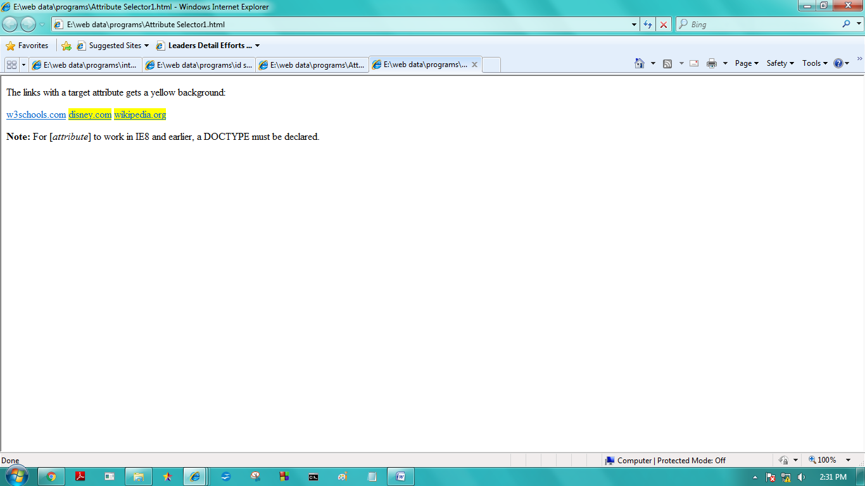

# ID SELECTOR

<html><head><style>

#para1 {text-align: center;

color: red;}

</style></head><body>

<p id="para1">Hello World!</p>

<p>This paragraph is not affected by the style.</p>

</body></html>

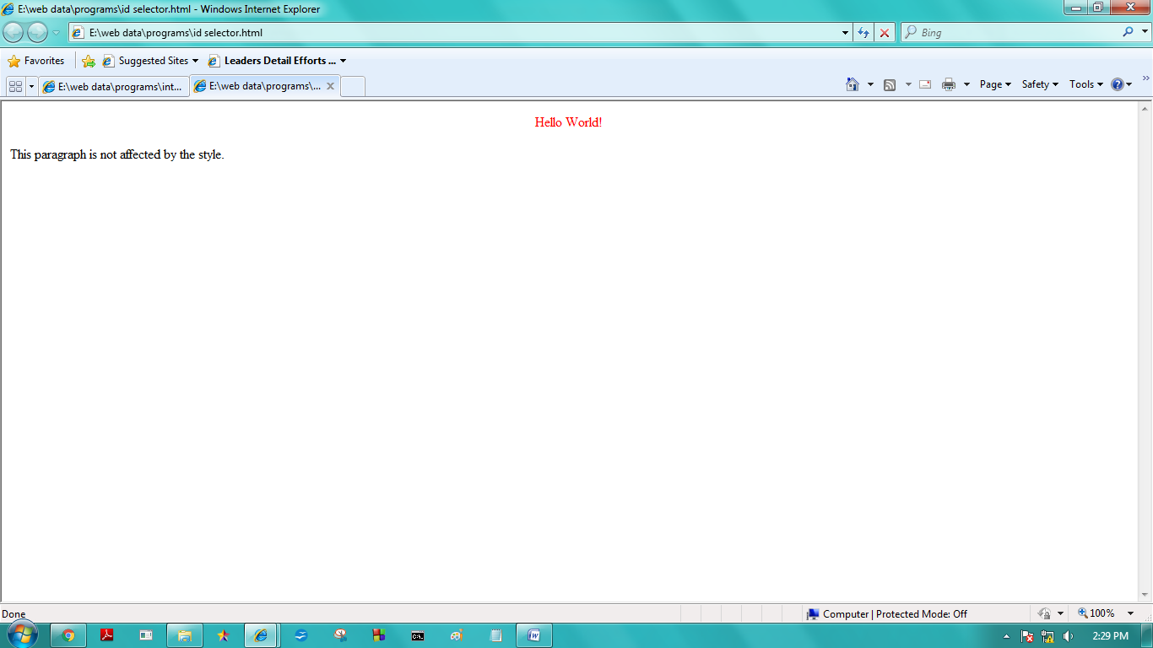

# INTERNAL CSS

<html><head>

<style type="text/css">

body {background-color: yellow}

h1 {background-color: #00ff00}

h2 {background-color: transparent}

p {background-color: rgb(250,0,255)}

</style></head><body>

<h1>This is header 1</h1>

<h2>This is header 2</h2>

<p>This is a paragraph</p>

</body></html>

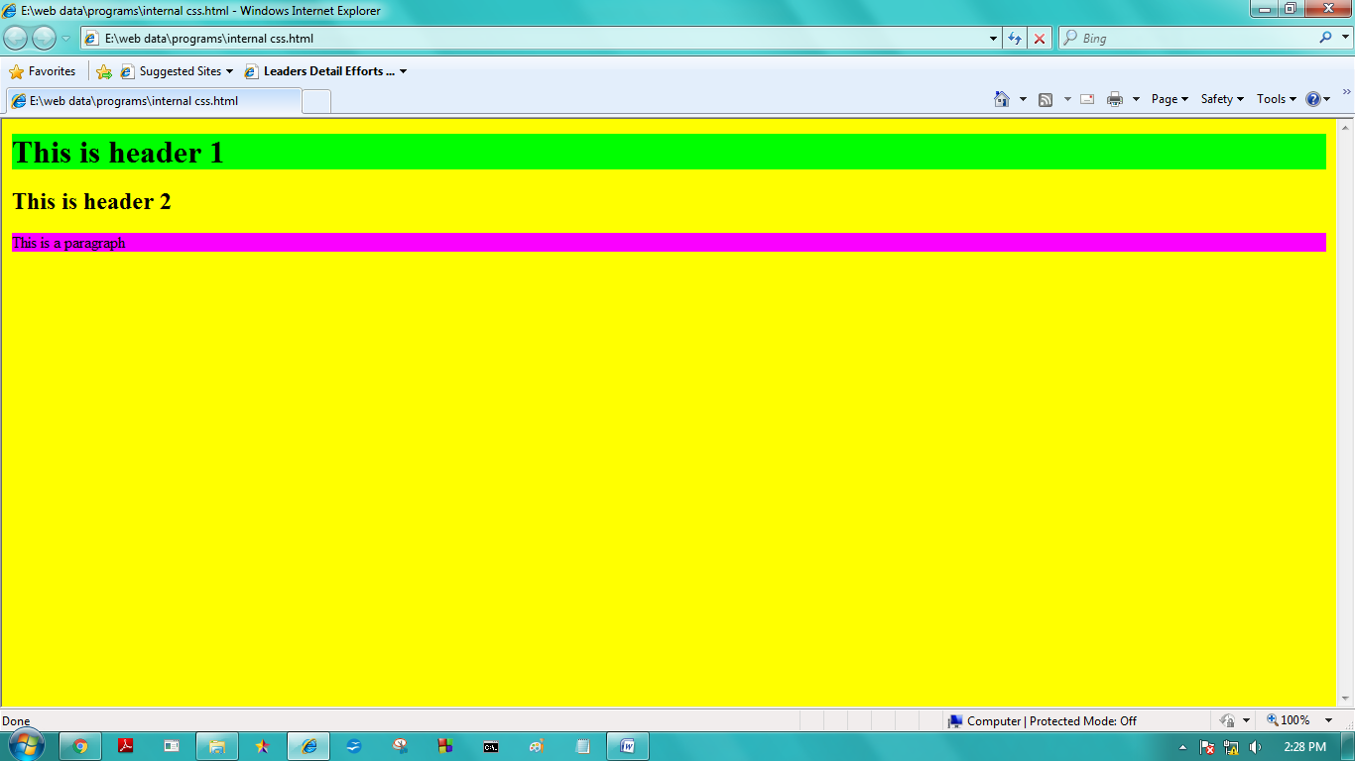

# EXTERNAL CSS

**Ex1.css**

body {background-color: tan}

h1 {color:maroon; font-size:20pt}

hr {color:navy}

p {font-size:11pt; margin-left: 15px}

a:link {color:green}

a:visited {color:yellow}

a:hover {color:black}

a:active {color:blue}

**Htmlcss1.html**

<html>

<head>

<link rel="stylesheet" type="text/css" href="ex2.css" />

</head>

<body>

<h1>This is a header 1</h1>

<hr />

<p>You can see that the style

sheet formats the text</p>

<p><a href="http://www.google.com" target="_blank">

This is a link</a></p>

</body>

</html>

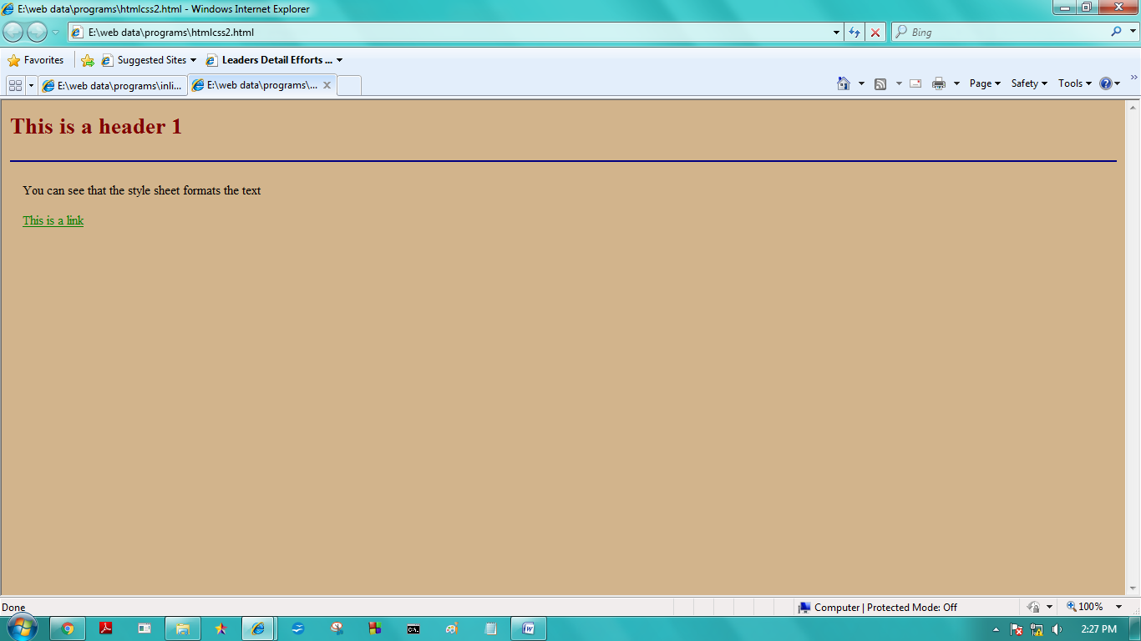

# INLINE CSS

<html>

<head>

</head>

<body>

<h1 style="background-color: #00ff00">This is header 1</h1>

<h2>This is header 2</h2>

<p style="background-color: rgb(250,0,255)">This is a paragraph</p>

</body>

</html>

